Document title
  - Subtitle (if you need it)

Author(s): | Lead author: Name Surname  Co-authors: Name Surname, Name Surname
Version: | 1.0
Date: | DD. MM. YYYY

Contents
Abbreviations 3
Executive summary 3
1 Heading 1 4
1.1 Heading 2 4
1.1.1 Heading 3 4
1.1.2 Heading 3 4
2 Figures and tables 4
3 Another chapter of the document 5
3.1 Another subchapter 5
3.1.1 Another subchapter of third level 5
3.1.2 And so on 5

This report arises from the Innovative Partnership for Action Against Cancer Joint Action, which has received funding from the European Union through the Consumers, Health, Agriculture and Food Executive Agency of the European Commission, in the framework of the Health Programme 2014-2020. The European Commission is not responsible for the content of this report. The sole responsibility for the report lies with the authors, and the Consumers, Health, Agriculture and Food Executive Agency is not responsible for any use that may be made of the information contained herein. The authors are not responsible for any further and future use of the report by third parties and third-party translations.

Abbreviations
CHAFEA | Consumers, Health, Agriculture and Food Executive Agency
EU | European Union
iPAAC | Innovative Partnership for Action Against Cancer

Executive summary
Text

Heading 1

Heading 2
Text

Heading 3
Text

Heading 3
Cancer continues to present one of the key public health challenges in the European Union. Over the last 8 years, we have seen an intensification of the activities at the level of the European Union in order to tackle cancer from different aspects. Still, a number of important outstanding issues in cancer control remain unaddressed. The Innovative Partnership for Action Against Cancer (iPAAC), which has been selected for funding under the Third Health Programme 2014–2020, aims to build upon the outcomes of previous EPAAC and CANCON Joint Actions.
Bullet list:
- Item 1
- Item 2
- Item 3
Numbered list:
- Item 1
- Item 2
- Item 3
The general objective of the iPAAC Joint Action (JA) is to develop innovative approaches to advances in cancer control. The innovation that will be covered within the JA consists of further development of cancer prevention, comprehensive approaches to the use of genomics in cancer control, cancer information and registries, improvements and challenges in cancer care, mapping of innovative cancer treatments and governance of integrated cancer control, including a new analysis of National Cancer Control Plans. The key focus of the Joint Action will be on implementation, reflected in the key deliverable: the Roadmap on Implementation and Sustainability of Cancer Control Actions, which will support Member States in implementation of iPAAC and CANCON recommendations.

Figures and tables
A short guideline how to handle tables, figures, and their captions. The captions should be BELOW a figure, but ABOVE a table.
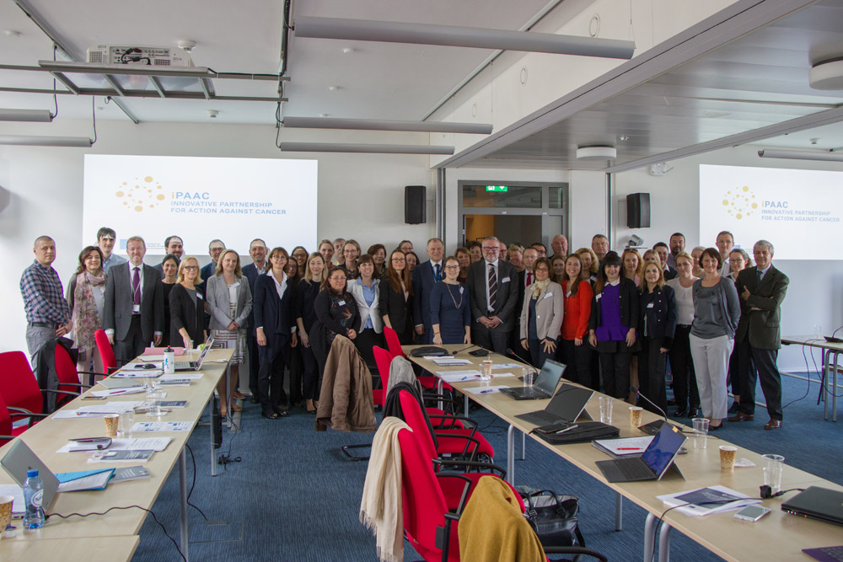
Figure 1. The iPAAC JA was launched in April 2018 in Luxembourg
Text
Table 1. iPAAC JA in numbers
Parameter | Value
Countries | 24
Competent Authorities | 24
Affiliated Entities | 20
Total | Not appropriate

Another chapter of the document

Another subchapter

Another subchapter of third level

And so on

